# Table of Contents

Table of Contents 2

Introduction 3

Abstract 3

Stage 1: Changing fan speed using potentiometer 3

Stage 2: Changing fan speed using Temperature Sensor TMP36 4

CODE SNIPPET 1 4

CODE SNIPPET 2 5

TEST CASE 1: Temperature = 23°C (between 20-25°C) 5

TEST CASE 2: Temperature = 27°C (between 25-30°C) 6

TEST CASE 3: Temperature = 65°C (>30°C) 6

Team Experience 7

# Introduction

The task allocated to the team was to simulate an Air Conditioning system that could change the speed of the fan depending upon the room temperature.

# Abstract

The system will include the functionality of changing the speed of the DC motor as the temperature of the room detected by the temperature sensor changes.

If a very low temperature is detected, the system shifts to its minimum mode, i.e, the fan speed is at its lowest. As the temperature sensed by the sensor gradually increases, the fan speed increases accordingly.

# Stage 1: Changing fan speed using potentiometer

In the first stage, instead of using a temperature sensor, a potentiometer is used to simulate the readings of sensor. Depending upon the rotation of the potentiometer, fan speed is increased or decreased.

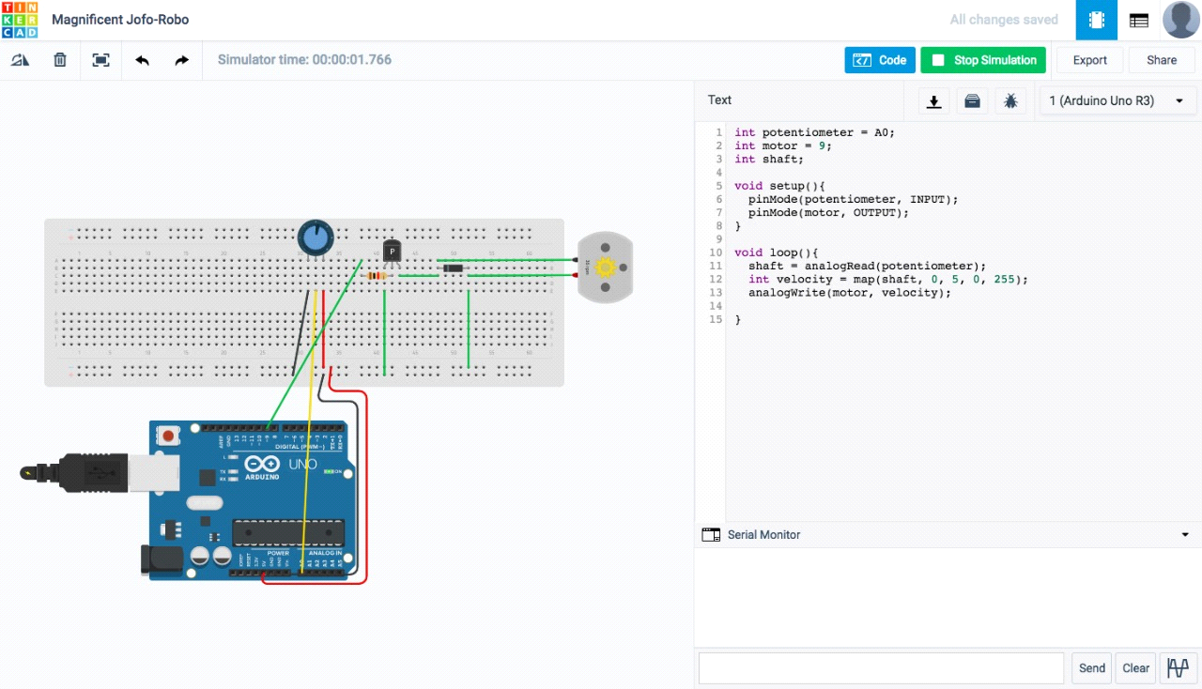

This stage enabled us to understand the mapping of rotational values of the potentiometer to the DC motor. A new component was introduced, i.e, the DC motor. The team understood and implemented the DC motor circuit.

# Stage 2: Changing fan speed using Temperature Sensor TMP36

In the second stage, we replaced the potentiometer with the temperature sensor- TMP36. It provides the readings according to the Celsius scale. The temperature sensor slider provided in the TinkerCad simulator was used to change the temperature readings. The fan speed was varied accordingly.

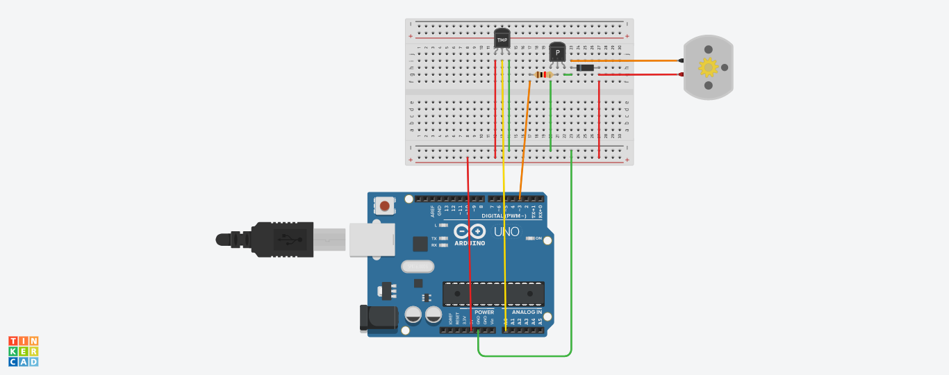

## CODE SNIPPET 1

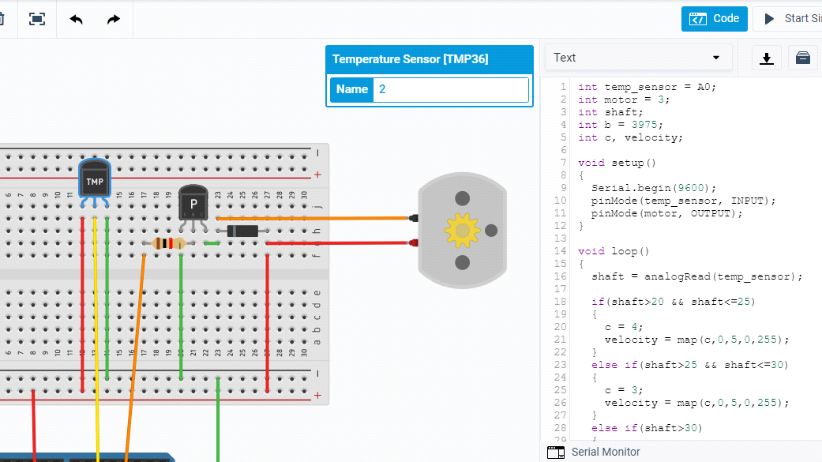

## CODE SNIPPET 2

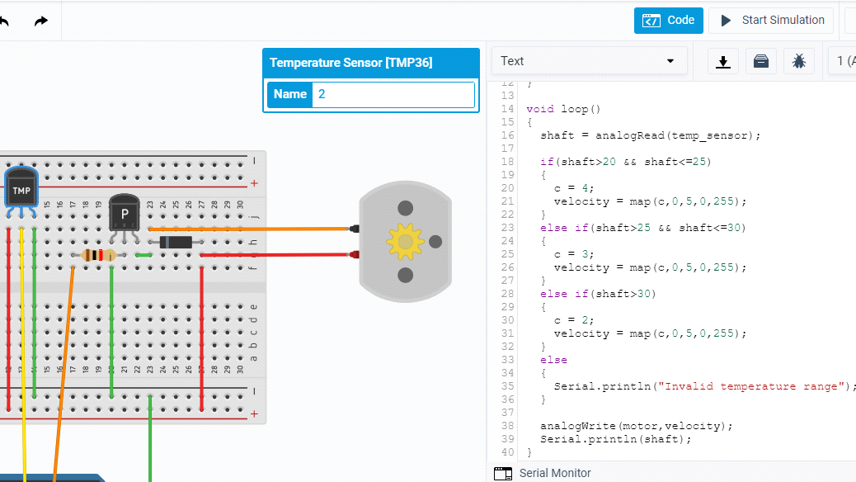

### TEST CASE 1: Temperature = 23°C (between 20-25°C)

Result: Fan speed = 256 rpm

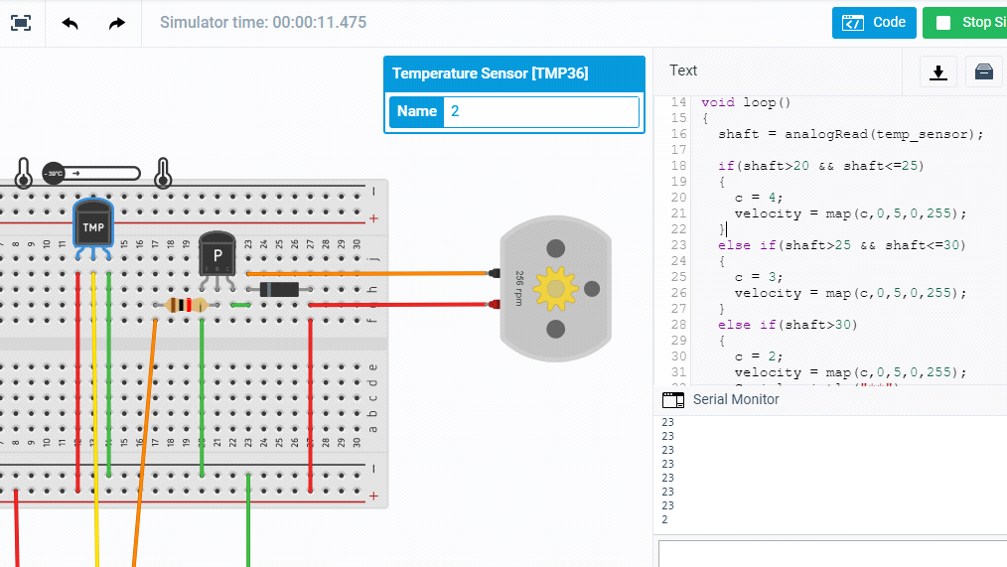

### TEST CASE 2: Temperature = 27°C (between 25-30°C)

Result: Fan speed = 480 rpm

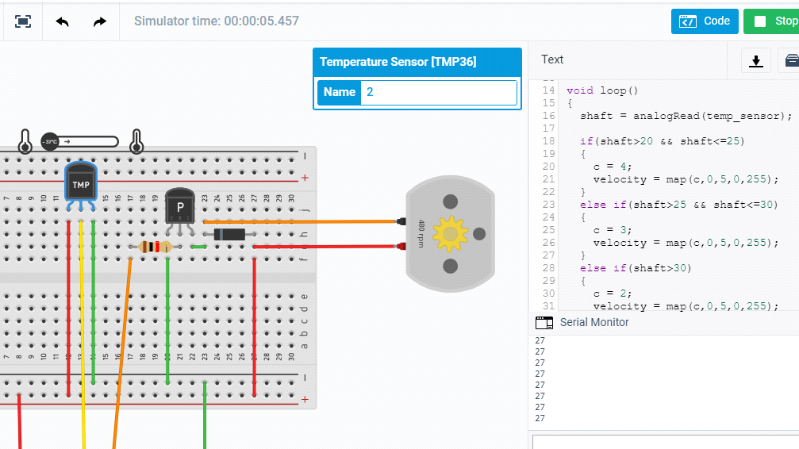

### TEST CASE 3: Temperature = 65°C (>30°C)

Result: Fan speed = 770 rpm

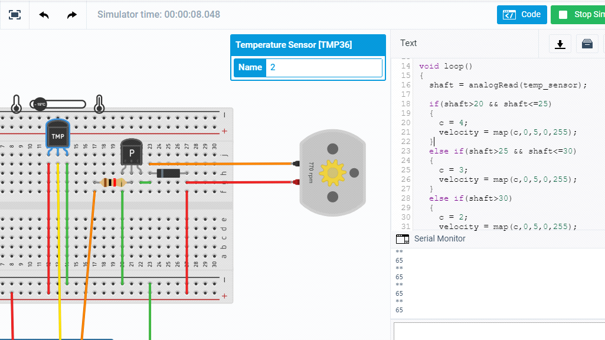

The team successfully implemented variation in fan speeds according to the changing temperature using the temperature sensor TMP36.

# Team Experience

The team enjoyed the experience of using new hardware devices and simulating the basic functionality of fan rotation speed. We aim to incorporate a few add-ons to this circuit in the future.